# Thought and Interfaces

This month’s column is, on the face of it, a whimsical undertaking. I’ll be examining the man-machine interface on two different cars – a 2004 Saturn Ion and a 2000 Infiniti I30. Yes, you are correct! I own some old cars and, just in case your thoughts wander into the notion that at least there is a luxury car in the mix, please note that the Infiniti was purchased used, with over 100,000 miles on it. Anyway, the central theme of this post is not what kind of cars I own and drive but rather what the design of the car tells about the designer.

The idea that the form and function of a work reveals a portion of the mind of the designer is old, very old, and is one of the central arguments from the medieval synthesis for the existence of God. I’m not claiming any deep metaphysical insights from the discussion here but I do think there are interesting reflections on the human mind in this very tongue-in-cheek analysis.

To start, let me say that the Infiniti is the better designed car from the point of view of acceleration, handling, and space. It has a V8 compared to the Ion’s 4 cylinder inline. It has leather seats versus the Saturn’s cloth ones. And the list could go on. Nonetheless, the man-machine interface in the Saturn is hands down better.

Let’s start with the power locks on the doors. Here is a picture of the locking control for the I30:

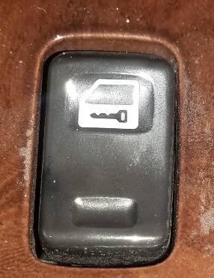

and the corresponding look at the Ion:

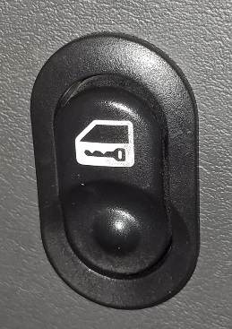

While they are very close in design they don’t work the same way at all – leading to a great deal of confusion whenever I switch. The icon of the black key on the white background means unlock on the Saturn and lock on the Infiniti. And that difference speaks to how the people who designed these controls think.

I am quite aware that there are cultural differences between the Japanese and US mind but these shouldn’t have come into play. That isn’t to say that they aren’t important or valid differences nor that the resulting man-machine interface isn’t influenced by them but rather there should be universal agreement across both designs.

The primary purpose of any key, regardless of the time and place in which it is used, is to unlock a locked door. In certain, older circumstances keys are also used to lock the door again but this lesser purpose should not be the one that the designers seized for their manufacturing. This is because, for reasons of safety and security, a car is something that is generally in a locked state unless being entered or exited. Once in a car, especially one that has power locks, the notion of key as the locking agent becomes almost meaningless. In addition, cars are imported and exported around the world and international standardizations are commonplace. Thus, the only possible conclusion is that the Ion gets it right and the Infiniti gets its wrong. This conclusion also suggests that the Infiniti designers were perhaps focused on the Japanese interpretation and not on how their product would be used in the global market.

Of course, there are those of you who still object that this is simply a matter of convention; that the functional argument is not persuasive. I must admit that when I first encountered this difference I wasn’t swayed either. The interface that really draws the difference and pushed my thinking from equivocation to certainty is the windshield wiper control. Here the problem isn’t embracing a difference between conventions but a matter of internal consistency. And again, the Saturn is the clear winner.

To be concrete, here is a photo of the interface to the wiper system from the Ion

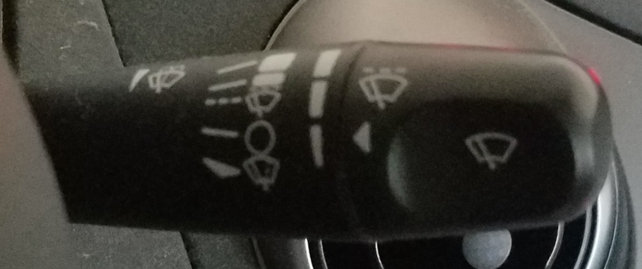

and the I30

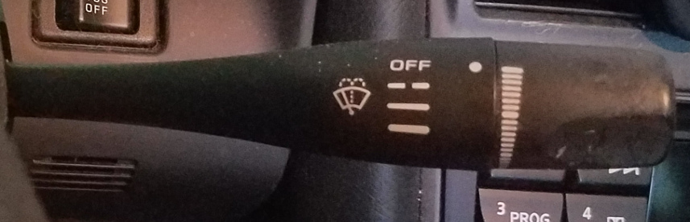

Again, the two designs look very similar – too similar, in fact, to keep me from getting confused. Both designs sport the traditional iconography of a dashed line (- -) for intermittent wipers, the solid line (—) for continuous low, and a heavy solid line for continuous high (**—**). A careful examination reveals that the directions one must articulate the control is different; on the Ion, the wipers go from intermittent to low to high by pushing the lever upwards while on the I30 the same sequence results by pushing down. Again, the difference seems to be one of convention but we haven’t discussed the intermittency setting and it is here that the I30 shows itself to be inconsistent.

Before getting to the inconsistency, there is one more matter of convention that differs between the two. Both controls sport a dial bearing graduated lines (the white lines on the right that are wider at the top and taper to almost nothing at the bottom). that set the speed of the intermittent wipers. For the I30, the larger the line the larger the time gap between successive swipes by the wipers. For the Ion, the larger the line the smaller the time gap between successive swipes. So their conventions are dual to each other, with the I30 working in terms of time and the Ion in terms of frequency.

The inconsistency rears its head when the lever and dial are used in tandem (i.e. when using intermittent wipers). In the I30, higher frequency is obtained by pushing the lever down but by turning the dial up. On the Ion, up means the same thing for both lever and dial. And that, in a nutshell, is why the man-machine interface of the Ion is better than that of the I30, despite the I30 being a better car overall.

So, what do these design choices reveal about the minds of the designers. In the case of the Ion, it seems to show that there was one single guiding mind or principle. Whether you prefer the design choices of the Ion over the I30, there is no arguing that the Ion design is self-consistent. White icons always mean changing the state to something more active from the previously passive state. For the doors from locked (passive) to unlocked (active); for the wipers from off (passive) to low frequency (active) to high frequency (more active). In the case of the I30, the design is a hodge-podge of concepts with differing motifs and little consistency. This suggests that no single guiding principle that knitted the design of the man-machine interface. Part of this is, no doubt cultural, but part of it seems to be indicative of a company that puts pride in the subsystems but fails to put as much emphasis on knitting the systems together in a seamless whole.